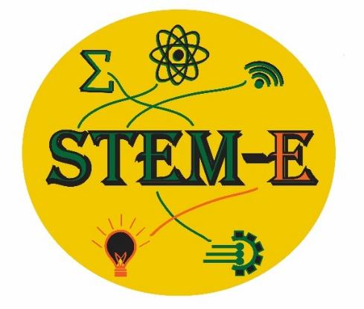

Spring STEM-E Conference Schedule
2024
8:45 am - 9:30: Schools Arrive & Check-In
Gather in MS Auditorium (CAC)
9:45 am – 11:00 am-Workshop I

11:05 am: Lunch meets at the Gathering Place

11:30-Transition to 2nd Workshop (ROTC)

11:45-1:00 pm-Workshop II

12:55pm - 1:00: Dismiss Load Buses

*Cherokee High School JROTC Cadets will assist you in locating your rooms.

Please refrain from taking photos in the CCS hallways.
STEM-E gratefully acknowledges the following organizations
and dedicated volunteers who provide an
engaging learning experience for our students:

- Cherokee Preservation Foundation for their vision and belief in the power of student engagement
- Duke Energy Foundation
- TELUS Foundation
- Smoky Mtn STEM Collaborative NASA
- Local Government Federal Credit Union
- Cherokee High School JROTC Cadets
- All presenters for designing and leading our workshops

- A special Thank you to CCS Superintendent Consuela Girty, Dr. Beverly Payne, Carmen Davis, Technology Director, Debora Foerst, Joel Creasman, Paula Coker, Nathan Barker, Heath Robertson, Kenitra Corbin, Shawn Crowe, Carmen Davis, Daphne Driver, Brett Robertson, Dr. Emily Darling, Dr. Jan Webster, WRESA, Duke Energy Foundation, TELUS. All school district STEM-E Leaders whose organizational skills and technical knowledge made the conference happen!
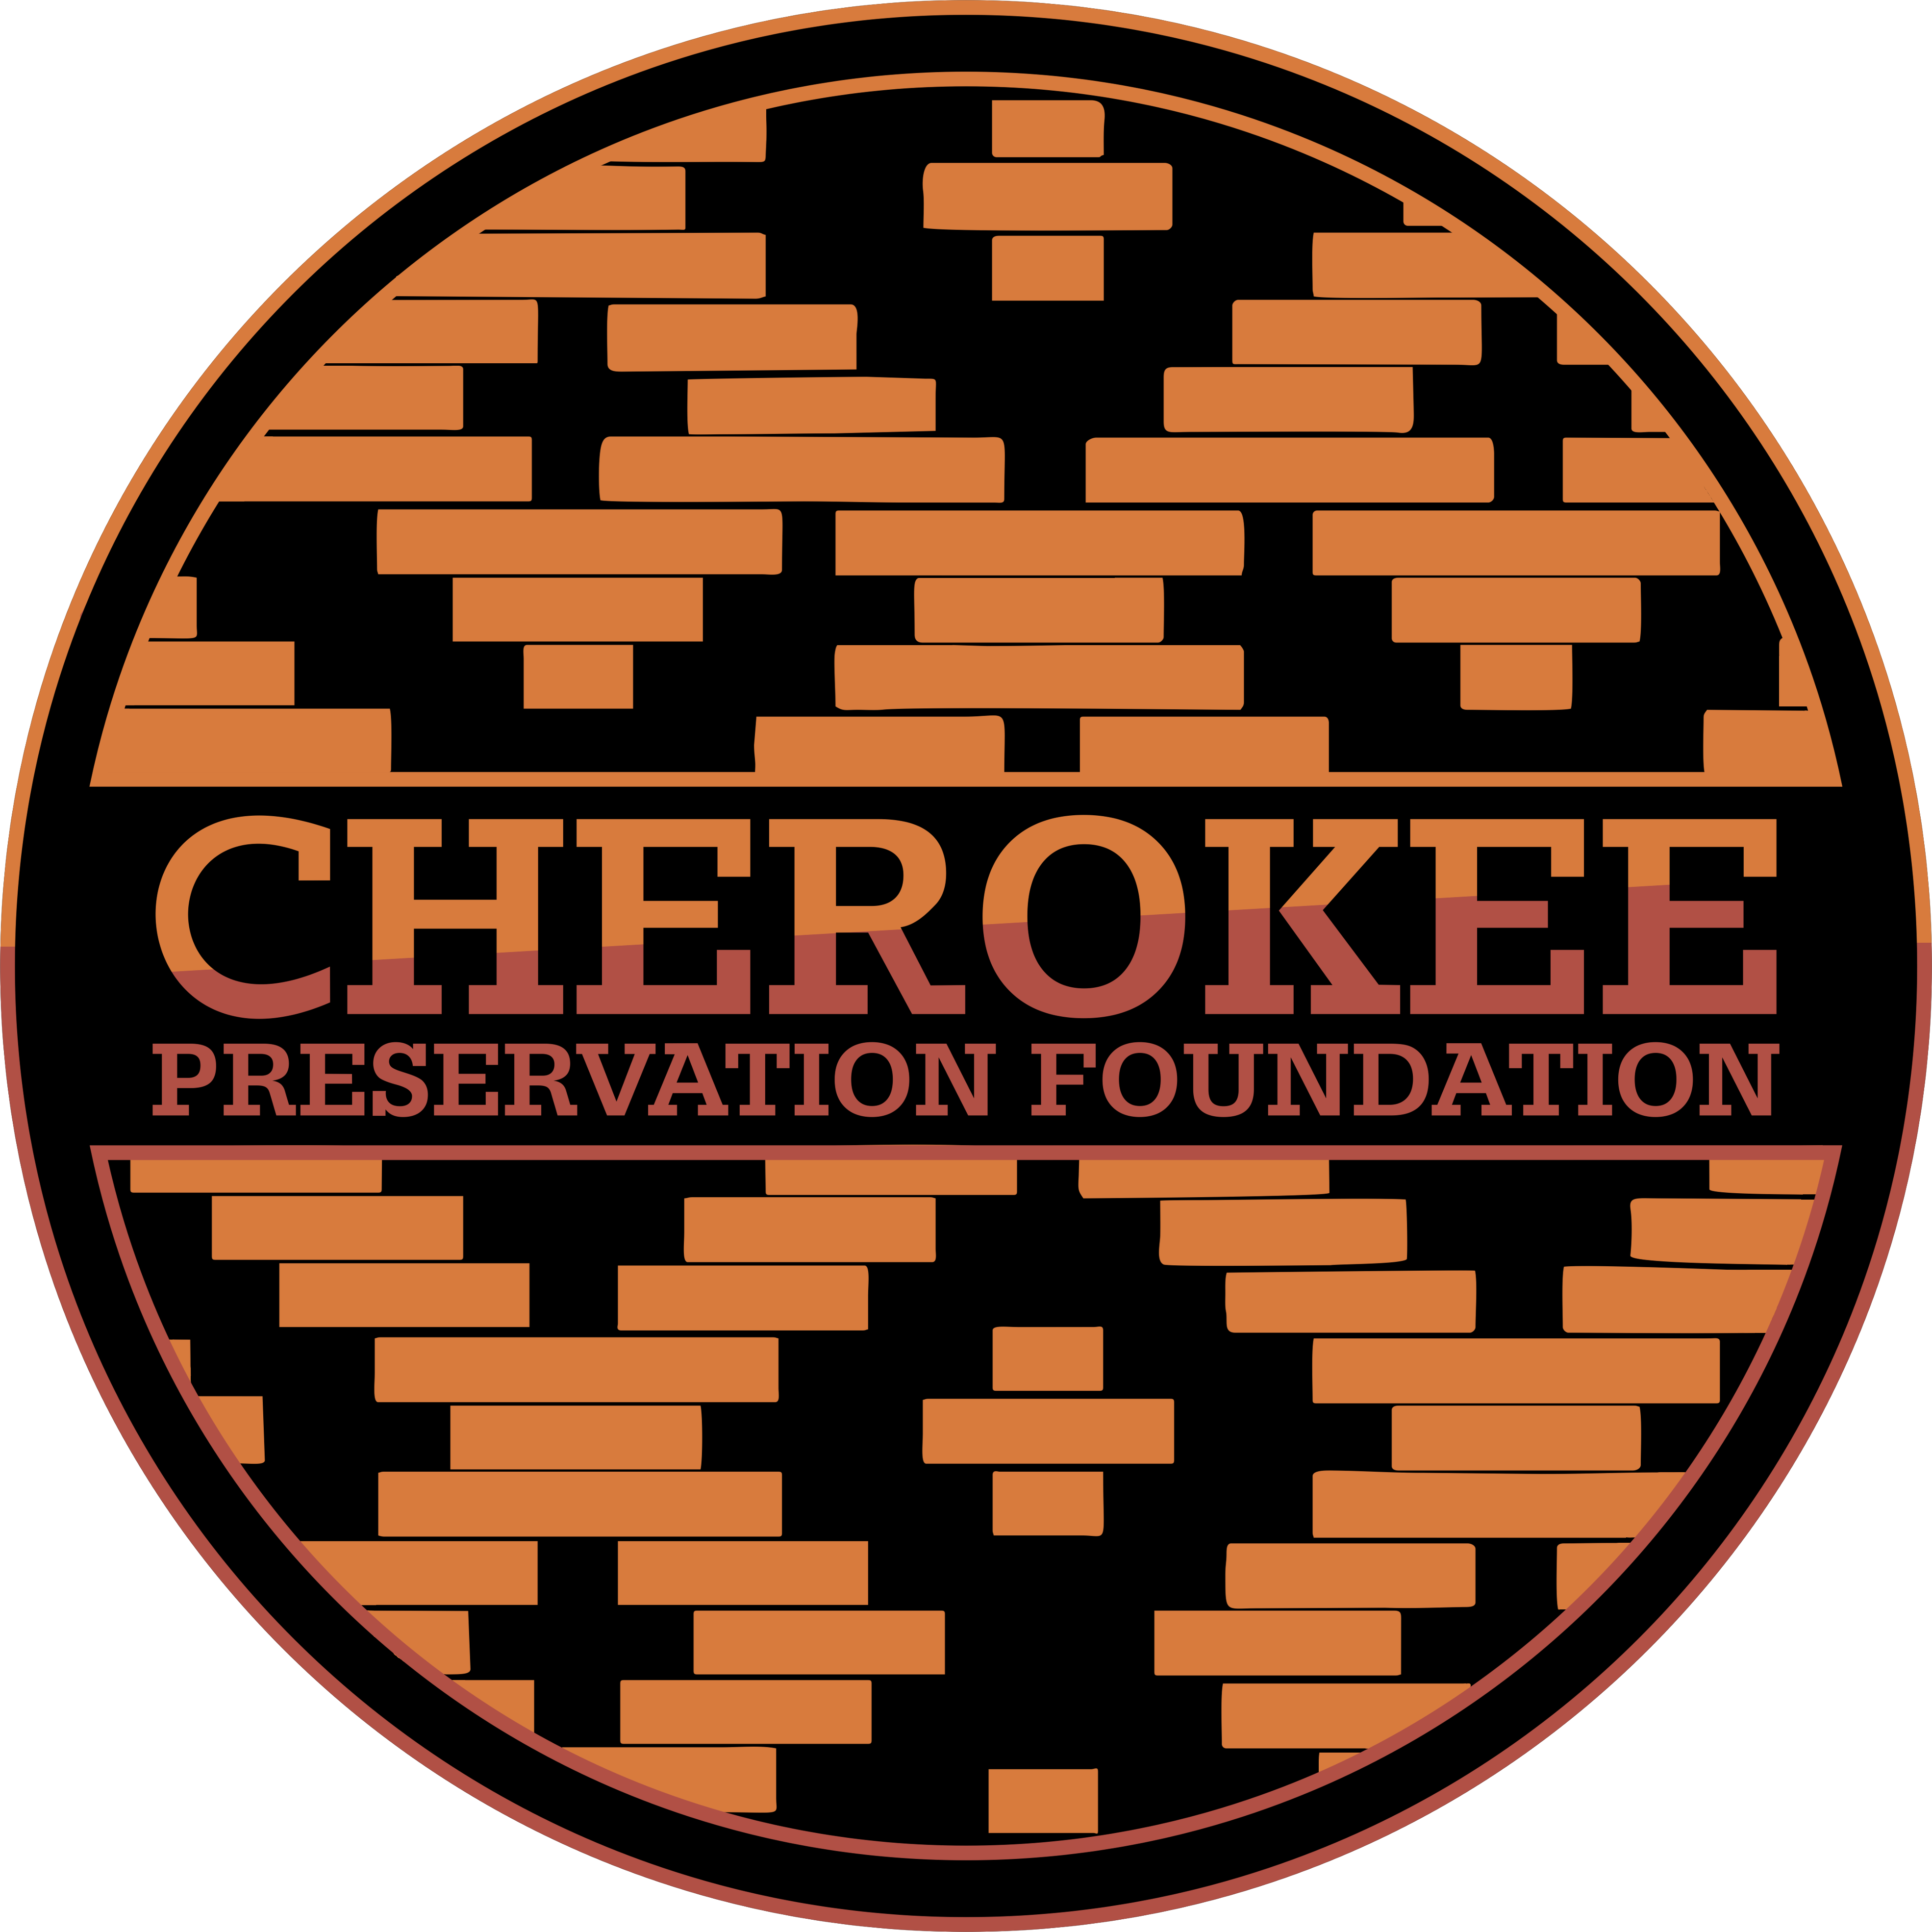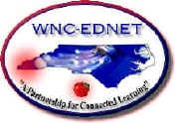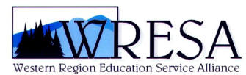

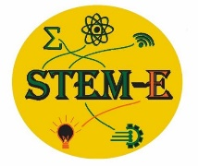
Welcome to the STEM-E SPRING ES/MS Student Conference
Morning and Afternoon Session Locations -Thursday, April 25-CCS Campus

STARWARS-Robotics

Sphero robot programming - from the creators of Star Wars bb-8
The Sphero robot was inspired by the inventors of the real Star War's bb-8. You will work with block coding with an interactive robot that will roll around, jump and be able to play games. During this session, you will do a bit of free driving around the room, program the robot to go and do what is needed to do to solve specific tasks.
Scott Freeman-CC Math Instructor

ecoEXPLORE -Discovering how students can participate in helping scientists track wildlife populations. The NC Arboretum staff will focus on herpetology and how students can share observations about reptiles and amphibians and earn their own science tools as well!
Nicholas Braylan, UNCA-
Assistant Director of Campus Recreation - Sports/Esports
UNC Asheville
E-Sports
An interactive presentation exploring STEM activities in the gaming realm, what types of jobs there are, what tools need to be learned to execute them, all while using popular game play as an example.

"Power Protectors" –
Collaborate and use your critical thinking skills in order to solve problems related to Renewable Energy and Sustainability.
Leah Jorgensen
4-H Youth Development
Haywood County Center
NC Cooperative Extension

Atsila Anotasgi (Fire Builders), Museum of the Cherokee Indians, Cultural Specialists
Rotate through 2 stations to learn more about Cherokee Culture
Location: Outdoor Session – School Track-Rain-Multi Purpose Room

Animal Adaptations Game- Students will examine 3-D Printed skulls to observe physical adaptations of some animals that make the Smokies a special place! Students will learn about the adaptations that different culturally significant mammals have in their anatomy, as well as learn about Cherokee stories of how those animals came to have those traits.
Presented By: Malia Crowe Skulski
Education Park Ranger - NC
Great Smoky Mountains National Park-Office: 828-497-1907 Cell: 414-587-1503

Mainspring Conservation Trust
“In the Creek!” Aquatic Insects and Water Quality
This session will cover an aquatic insect collection activity, (weather permitting), where students will be able to enter the stream and learn various techniques for collecting aquatic insects. After collecting, we will learn about taxonomic
identification through rapid field assessment, discuss sampling efficiency and how we use these insects to tell us about the water quality of a stream.

We are excited to see what awesome things you can find in the creek!

Presented By:
Jason Meador
Aquatic Programs Manager
Certified N.C. Environmental Educator
Skye Cahoon, Conservation Outreach Associate

Discover STEM-Careers
In this session, students will participate in an interactive session where they will learn about more than 40 amazing STEM careers! They will get to "meet" women in these careers, understand how they make a difference in the world, and how they help people. They will leave the session with lots of advice and guidance to help them pursue a career in STEM, too!
Grace Moore, IBM Product Manager

Cherokee Art-Learn Cherokee Language through art and culture expression. CCS Cultural teachers will facilitate a weaving activity which encompasses math strategies and patterns used in in basket weaving.

