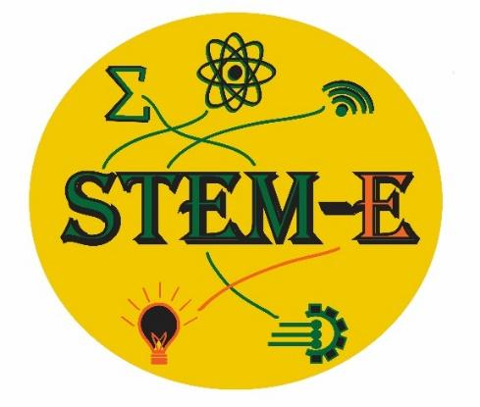
STEM-E SPRING ELEMENTARY/MIDDLE SCHOOL CONFERENCE

Morning and Afternoon SessionS -ES/MS Friday, April 28-CCS Campus

Introduction to Forensic Anthropology

This presentation will provide an overview of what forensic anthropologists do, as well as the forensic anthropology facilities at Western Carolina University. Following the presentation, students will have a chance to handle and ask questions with plastic skeletal remains.
Rebecca L. George, PhD
Forensic Anthropology Facilities Curator and Instructor of Anthropology
Western Carolina University
rgeorge@wcu.edu

“Huge Computers and Gigantic Explosions!”

Students will learn the basics of how the world’s most powerful supercomputers help to solve some of the world’s hardest problems, including how exploding stars produce the seeds of life.

Bronson Messer, PhD
Distinguished Scientist
Director of Science
Oak Ridge Leadership Computing Facility
bronson@ornl.gov

“Our Mountain Stories”

"Study various rocks and minerals found throughout the southern Appalachians and learn how they form and the stories they tell. Uncover how they shape the land we call home, and how they helped North Carolina become the economic success the Old North State is today. "

Holly Theobald
Lead Education Specialist
Highlands Biological Foundation
holly@highlandsbiological.org

Entrepreneurship- “Mix and Match”
Using Resources to Create a Successful Business- Participants will learn about how their community and access to resources can impact a small business. This interactive session will allow participants to work together to create businesses using their strengths, community attributes, and local resources.
Hope Huskey, Associate Director
Sequoyah Fund

“In the Creek!” Aquatic Insects and Water Quality
This session will cover an aquatic insect collection activity, (weather permitting), where students will be
able to enter the stream and search for aquatic insects. After collecting, we will learn about taxonomic
identification of these insects using a microscope and how we use these insects to tell us about the
water quality of a stream.
We are excited to see what awesome things you can find in the creek!
Rainee Tetreault
Lead Environmental Lab Technician
Eastern Band of Cherokee Indians
Water Quality Program
raintetr@ebci-nsn.gov
Dave Penrose, Principal
Penrose Environmental Consulting LLC
(919) 605-1394
dave@penroseconsulting
Fellow, Society for Freshwater Science

Max 20 students per session
“Making Slimy Slime”- Participants will learn about the properties of synthetic and biological polymers and explore their biological and industrial applications. During the workshop, students will make slime that they can take with them.
Dr. Channa De Silva
Professor of Chemistry
Western Carolina University-

Waves and Sound-Bhoom Whacker

How do musical instruments make music? Explore the fundamentals of waves, sound and resonance with springs, tuning forks, boomwhackers, and some everyday objects you can find around the house. Sound is produced by vibrating objects. The pitch of the sound can be varied by changing the rate of vibration.
Dr.Judith Beck
Senior Lecturer, UNC Asheville Dept. of Physics and Astronomy
jbeck@unca.edu

Mainspring Conservation Trust- “The Wood Wide Web!”
In this session, we will discover the magical underground world of fungal mycelium and how it contributes to a healthy forest community. Students will also learn why mycelium produces mushrooms, what the function of a mushroom is, and tips and tricks for identifying the mushrooms in their own backyard. After a brief introductory lesson, we will explore the forest and see what types of mushrooms and mycelium we can find and identify! Dress for outside activity.
Jason Meador
Aquatic Programs Manager
Certified N.C. Environmental Educator
Skye Cahoon, Conservation Outreach Associate

“Scavenger Hunt” Walk with the Eastern Band of Cherokee Indians Natural Resources Department as they lead you through a scavenger hunt. During the pursuit we will explore and identify native flora and fauna including animal pelts, tracks, skulls, and more! Not only will you walk away with the ability to use a scientific tool to identify organisms in your own backyard, but you will have a renewed appreciation of your environment. Bring your PAWsitive attitude and be prepared to think like a naturalist!
Desirae Kissell
Eastern Band of Cherokee Indians
Conservation Outreach Coordinator
Cell: (828) 788-0219
desikiss@ebci-nsn.gov

Wi-Fi for Presenters: Password:

